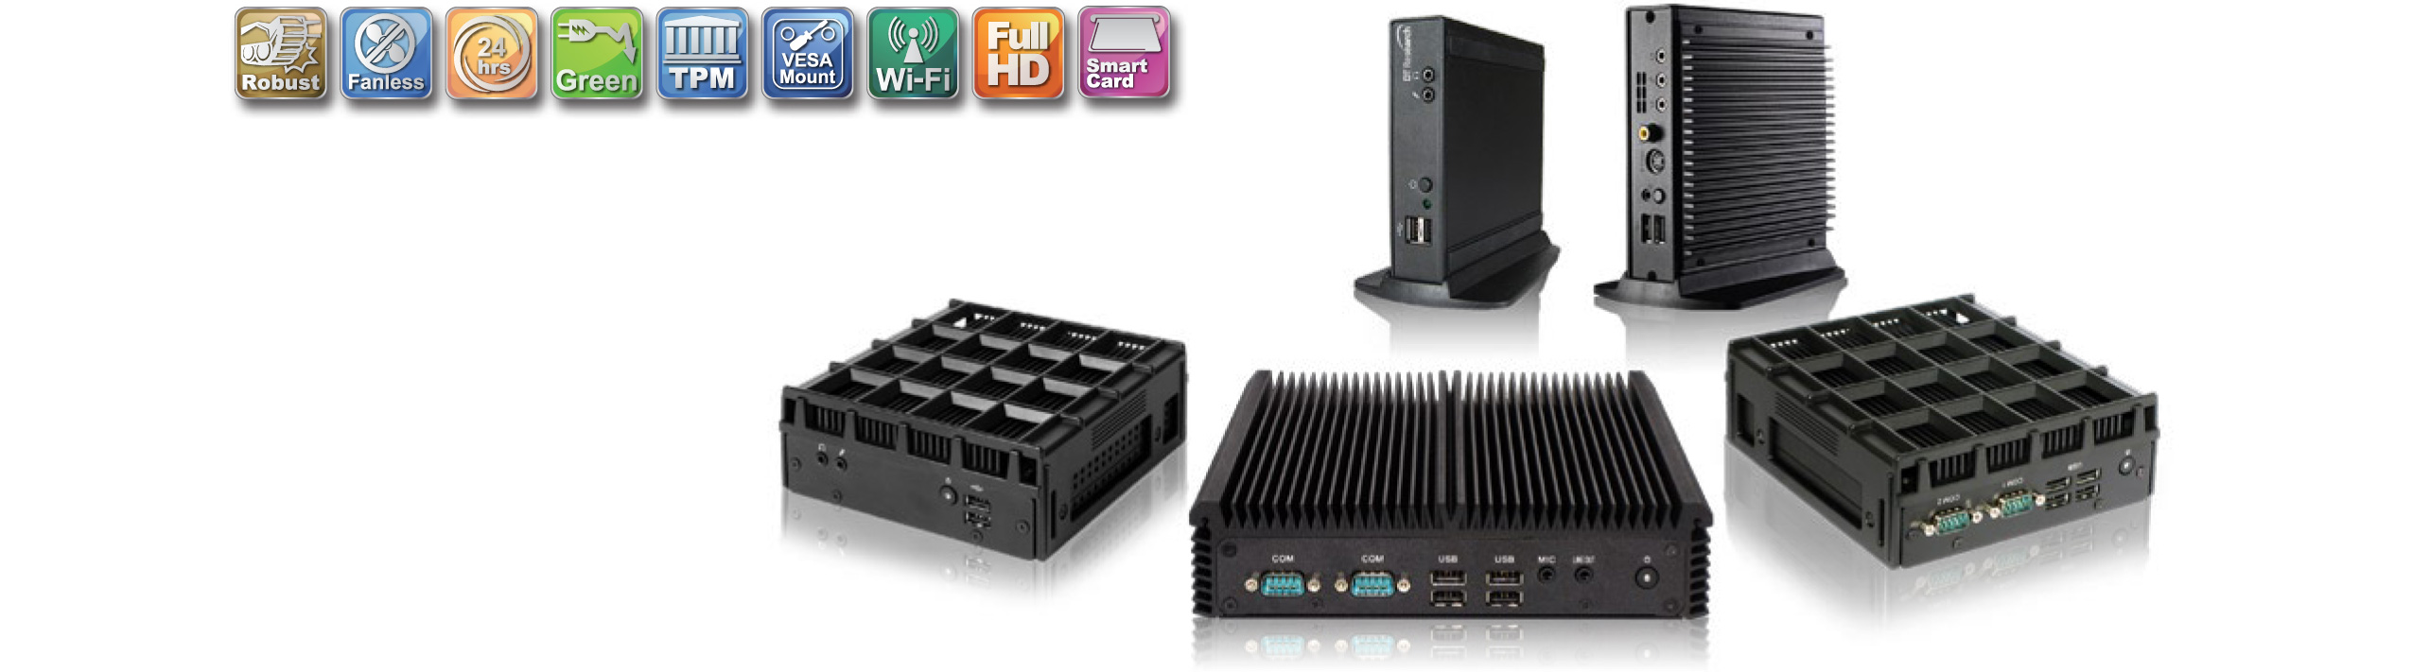


DPC136PS64

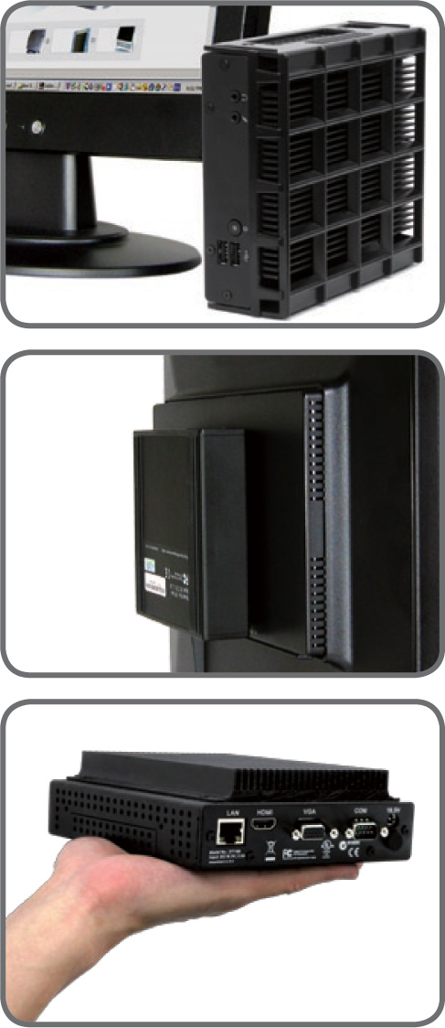
The DPC136 Embedded Controllers/ Systems offer low cost yet elegant solutions in robust packaging designed for flexibility in location and orientation. The compact design of the products is complemented by USB, networking, audio and display ports with available wireless options.
A selection of operating software offers optimal user experience for Internet/Intranet access and server-based computing.



Applications:

The DPC136 Embedded Controllers/ Systems are ideal for
the following applications:

- Control / Monitoring
- Inventory / Warehousing
- Manufacturing
- Entertainment / Gaming
- Education
- Retail
- Hospitality
- Healthcare

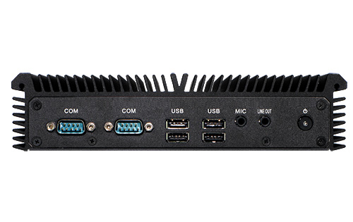
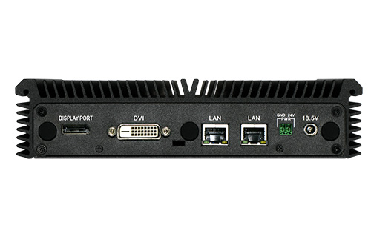

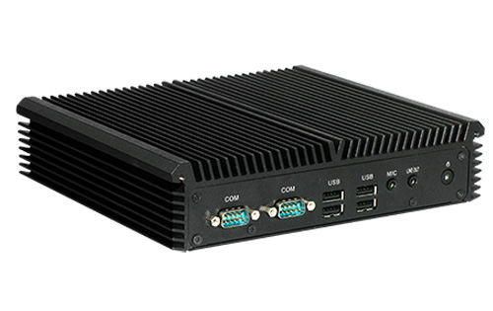
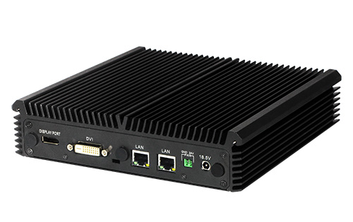


Specifications:
System
CPU | Intel® Core™ i3
GPU | Intel® HM76
RAM | 4GB to 8GB
Storage | 64GB
Operating System | Microsoft® Windows® Embedded Standard 7
TPM | TPM 1.2
Display Resolution | Up to 1920 x 1080
Network Interface | 10/100/1000MB BaseT LAN x 2; Wi-Fi 802.11 a/ b/g/n (optional)

I/O Ports
Expansion | Mini PCI
HDMI | 1
VGA | N/A
DVI | 1
Audio Jack | 2
USB 2.0 Port | 4
Serial/ COM | 2
Parallel | N/A
DC-in | 2 (include Phoenix connector for 12-24V DC in)
Optional Ports | Wi-Fi dipole antenna

Mechanical and Environmental
Fan/ Fanless | Fanless
AC/DC Adapter | Input: 100-240 V AC; Output: 18.5V DC / Phoenix: 12-24V DC, 3.5A
Enclosure | Aluminum + steel
Dimensions (H x W x D) | 2 x 8.3 x 7.87 in / 50 x 210 x 200 mm
Weight | 5.51 lbs/ 2500 g
Regulatory | FCC Class B, CE, C-Tick, UL, RoHS compliant
VESA Mounting Bracket | Included
Temperature | Operation: 0°C – 40°C; Storage: -20°C – 60°C
Humidity | 0% – 90% non-condensing

* Specifications subject to change without notice.

i-Tech Company LLC
TOLL FREE: (888) 483-2418 • EMAIL: info@itechlcd.com • WEB: www.iTechLCD.com

