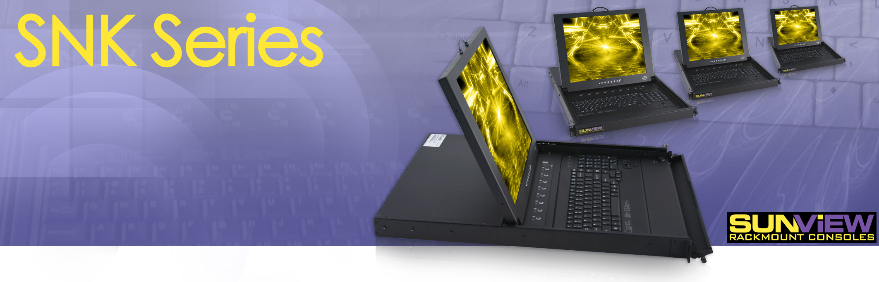
Model: SNK117C16

1U Sun Compatible Keyboard Rackmount
Monitor 17" LCD Drawer with 16-ports CAT5
KVM Switches Keyboard Drawer and USB KVM

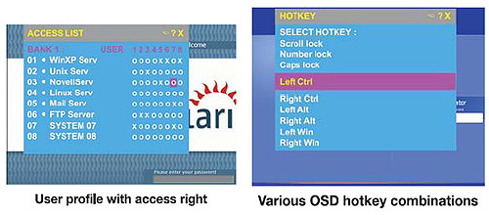
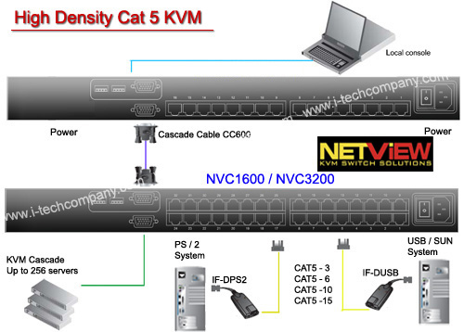
- Use of the RJ45 Cat5 interface allows for a higher number of ports in smaller density
- Greater distances between your switch and servers allow enhanced data centre rack layouts
- Traditional Cat5 cords, when compared to coaxial cables, provide simple cable management
- Mix legacy PS/2 servers with newer USB and SUN solutions
- Multi lingual on screen display menu
- Advanced user profiles and configurable OSD hot key combinations
- 12, 24 and 48 volt DC power options
- High density Cat5 KVM with either 16 or 32 ports in 1U
- Cost efficient DB-15KVM integration
- Single or “One Man” installation slide for easy, quick installation
- 104 key notepad keyboard with full numerical pad
- Mix PS/2, USB & SUN Multi-Platform switch capability
- Secure remote User access across the world wide web
LCD Drawer & KVM Benefits:
- 1U rackmount drawer with either 17" or 19" SAMSUNG LCD
- Either PS/2 or USB input to the LCD Drawer by cable selection
- Multiple keyboard language selections with either touchpad or trackball
- slide rails with fixed positions to prevent drawer movement when typing
- Multi lingual on screen display menu
- 12, 24 and 48 volt DC power options
LCD Features:
KVM Features and Benefits:

Mechanical Drawing:

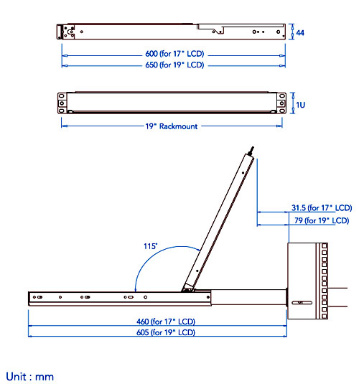

i-Tech Company LLC
TOLL FREE: (888) 483-2418 • EMAIL: info@i-techcompany.com • WEB: www.iTechLCD.com

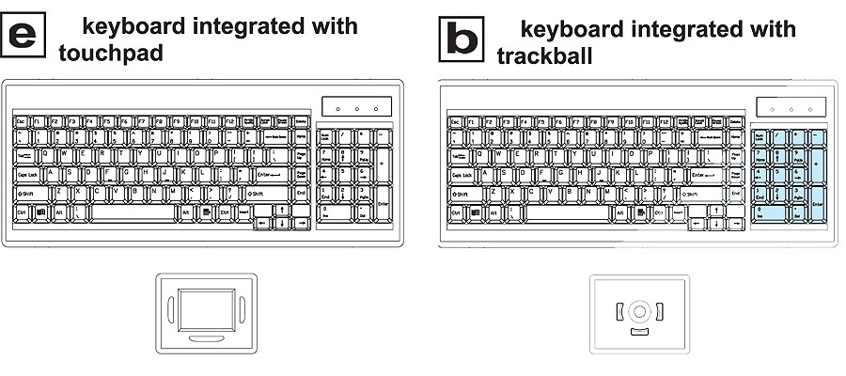

Specifications:
LCD
Panel | Samsung 17" LCD Panel
Screen Type | TFT
Display Area | 337.92(H) x 270.34(V) mm
Contrast Ratio | 500 : 1
Viewing Angle | 140 ° (H) x 120 ° (V) (Typ.)
Resolution | 1280 x 1024
Pixel pitch | 0.264(H) x 0.264(W) mm
Response Time | Tr=5ms, Tf=20ms (Typ.)
Brightness | 300 cd/m2
Panel Color | 16.2M
Back Light | 4 CCFTs (Cold Cathode Fluorescent tube)
Video
Horizontal Synchronization | 64 - 80 KHz (Typ.)
Vertical Synchronization | 60 - 75 Hz (Typ.)
Input Signal | Analog RGB 0.7Vp-p
Power Management
VESA DPMS
Control
OSD Control | Brightness, Contrast, Colour, Clock, H.Position, V.Position, Phase, Scaling, Auto config, Input select, Multi window, Clear EEPROM, OSD adjust, Save
External Connection
Power Input | 12V/5A DC adapter
Video Input | 15-pin D-Sub connector

KVM Port
Number of ports : | 16or32
Connector: | RJ-45
Connectivity: | USB type or PS/2 type dongle, up to 40 meter ( 130 feet)
Local Console
Graphic connector: | HDDB15-pin HDDB15-pin, VGA
Resolution: | Up to 1600x1200
Input device: | 2 x USB type A for keyboard & mouse
Management
Multilingual OSD : | English, France, German, Spanish, Italian, Russian, Simplified Chinese,Japanese
Hotkey combination : | Scroll-lock, Cap-lock, Num-lock, Alt, Ctrl & WinSecunity:
Secunity: | Password enable & disable, up to 8 users profile for port access
PC Selection: | Front button, OSD menu & hotkey
Expansion :
 | Up to 256 servers by 8-level cascade
Compatibility
Multi-platform | Mix PCs, SUNs, IBMs, HPs, DELLs Server
:Support: | Windows Vista, 2003 / XP / 2000, Linux, Netware, Unix
Power
Input: | 100-240VAC, 50 or 60Hz, IEC type cord
Option DC : | 12V/24V/48V DC input
Consumption : | Max. 25 Watt
Regulatory Approval
 | FCC,CE
Environmental
Operating : | 0 to 50"C
Storage: | -10 to 60-C
Relative humidity: | 90%, non-condensing
Shock: | 50G peak acceleration (11 ms, half-sine wave)
Vibration : | 58~100Hz / 0.98G (11 min / cycle)

KVM Technical Specifications:

i-Tech Company LLC
TOLL FREE: (888) 483-2418 • EMAIL: info@i-techcompany.com • WEB: www.iTechLCD.com

