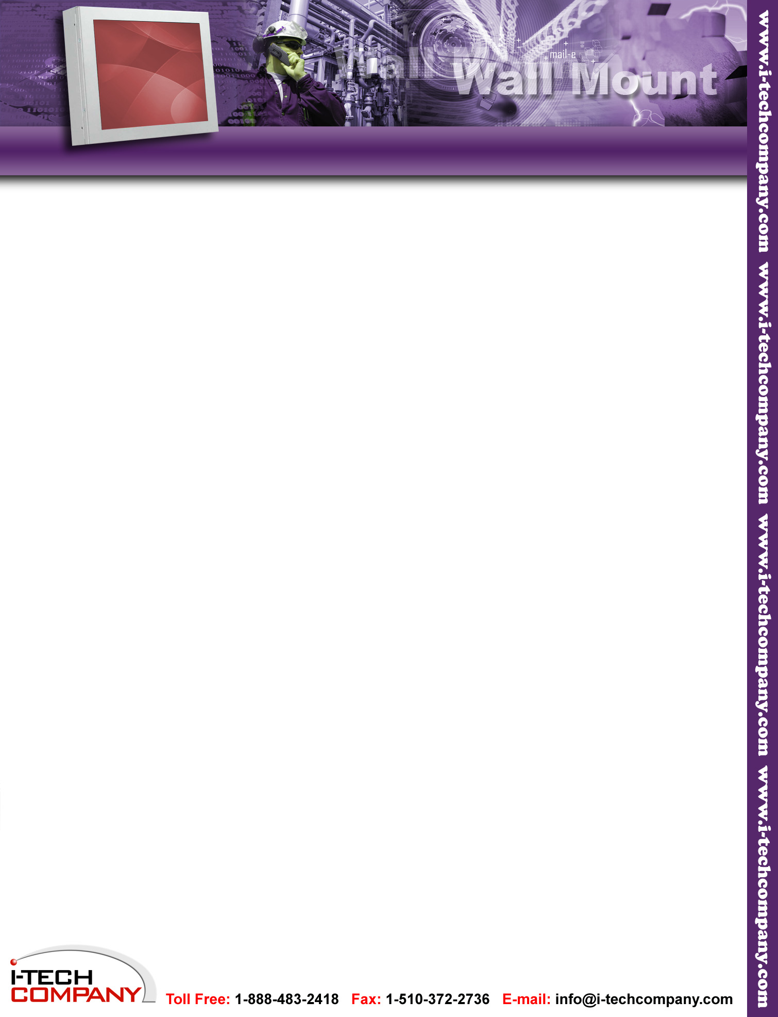
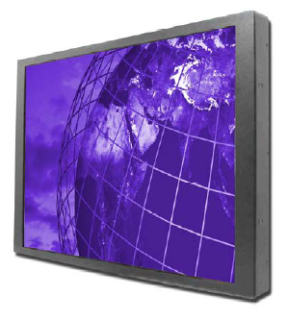
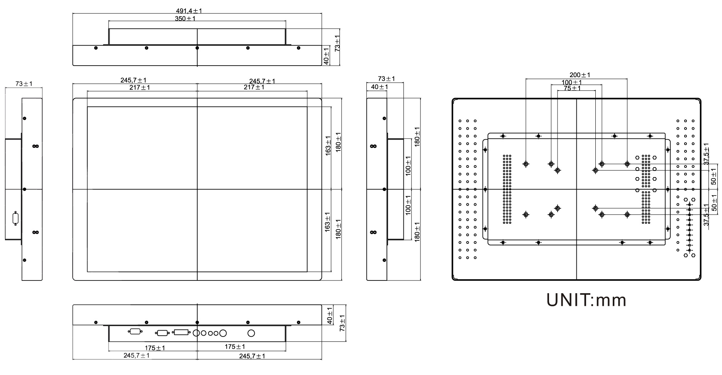
Remarks: WCH2130S1 series= VGA input only
WCH2130S1AV series= VGA+Video Input

MECHANICAL DRAWING
Specifications
Model Name | WCH2130S1
Viewable Size image | 21.3”
Active Display Area (mm) | 423(H)x324(V)
Pixel Pitch(mm) | 0.270 (H) x 0.270 (V)
Number of Pixels | 1600x1200
Contrast Ratio | 1000:1(typ.)
Display Colors | 16.7M(8bit/colors)
Brightness(cd/m ) | 300(typ.)
Viewing Angle(CR>=10) | -80~80(H);-60~80(V)
Synchronization Range Horizontal/Vertical  Horizontal/Vertical | 31.5~80.0KHz/60~75Hz
Recommended Resolution | 1600x1200@60Hz
Signal Connector | 15 pin D-Sub
Power Source | AC100~240V, Universal, 10%
Power Consumption | 60W typical, normal operation
Power Management | VESA DPMS Compliant
Plug & Play | VESA DDC 1/2B
Optional Video Input | S-Video, Composite
Optional DVI Input | Yes
Optional Touch Screen | Resistive

