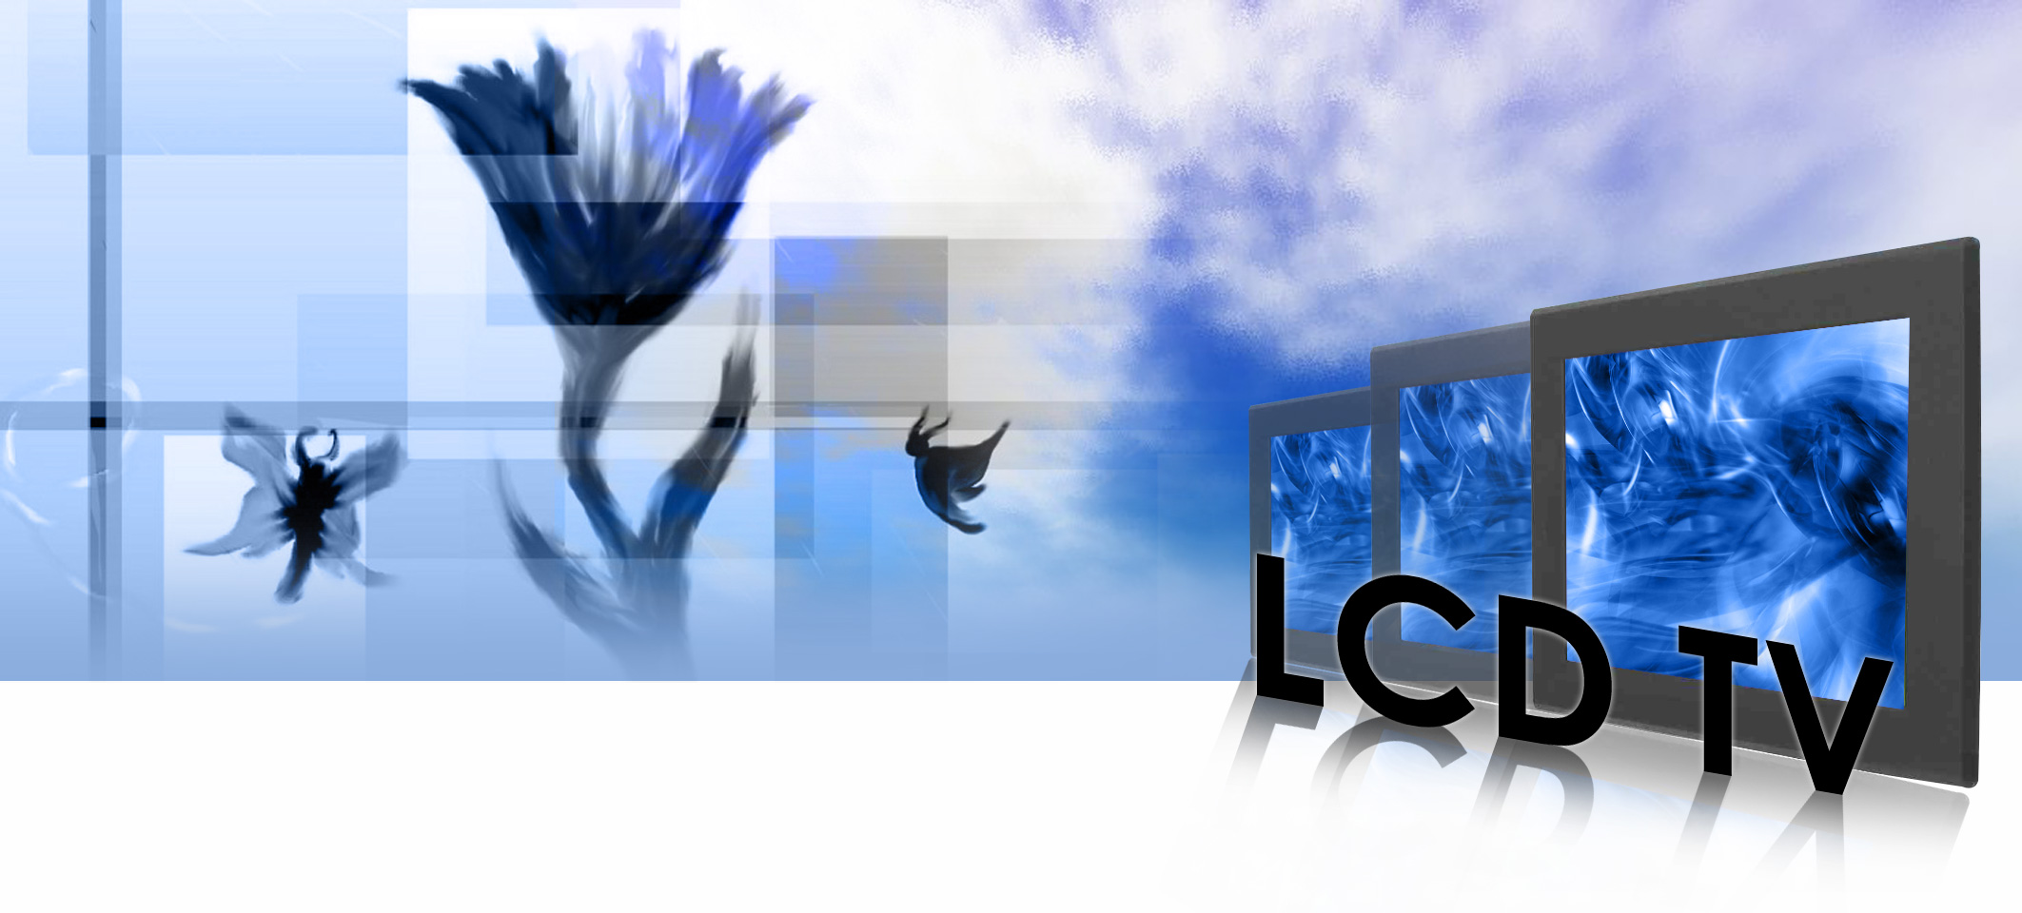

i-Tech Company LLC
TOLL FREE: (888) 483-2418 • EMAIL: info@i-techcompany.com • WEB: www.iTechLCD.com

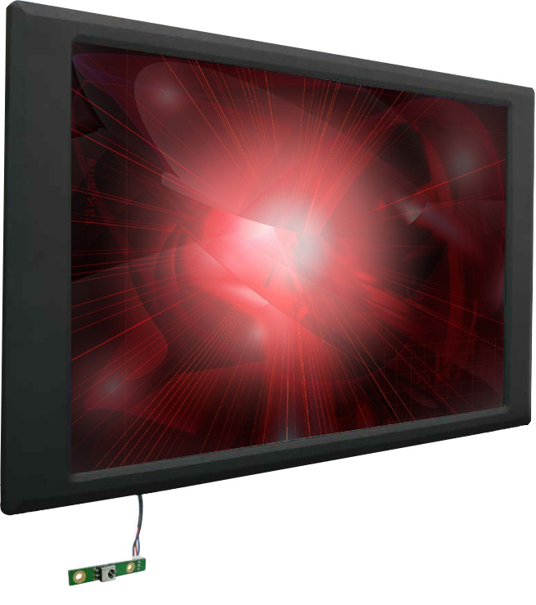

20.1” Panel Mount LCD TV

Model | WPMV2000A3
Panel | Type | 20.1" color active matrix TFT LCD
 | Active Display Area(mm) | 443.61(H) x 249.41(V)
 | Pixel Pitch(mm) | 0.325(H) x 0.325(V)
 | Number of pixels | 1366x768
 | Contrast Ratio | 600:1 (typ.)
 | Display Color | 16.2M(6bit/FRC)
 | Brightness | 450 cd/m2 (typ.)
 | Viewing Angles | -80° ~ 80° (H); -60° ~ 89° (V) (CR ≥ 10)
 | Response Time | 8ms (Grey to Grey, typ.)
INPUT | TV (Analog) | 1x F (or IEC) connector for ANTENNA or CATV signal
 | Video | 1x Composite (RCA)  1x S-video (4 pin Mini-DIN)
 | PC | RGB analog 15 pin D-sub
 | RGB Frequency | H: 31.5~80kHz, V: 60~75Hz
 | Audio | 1x 3.5mm stereo phone jack
 | Digital | DVI-D
 | Tuner | NTSC or PAL
AUDIO OUT | Speakers | 2x2Watt
POWER | Voltage | AC 100~240V, Universal, ±10%
 | Consumption | 71 W typical, normal operation
CONTROL FUNCTIONS | Basic | Power, Volume +/-, Channel +/-, Source, Menu
 | TV Mode | MTS, TV/CATV, Auto Scan, Channel Memory, Channel Delete,  Last Channel Recall, Timer for sleep(optional)
 | PC Mode | Brightness, Contrast, Color Temperature, Gamma, Scaling,  Auto Adjust, Phase, Clock, Position, Auto color,  PIP/POP, Reset
 | Video Mode | Brightness, Contrast, Scaling, Hue, Saturation, Sharpness,  Color Temperature, PIP/POP, Reset
 | Audio | Volume, Bass, Treble, Balance, Mute
OPERATING CONDITIONS | Temperature | 0-50 C
 | Humidity | 5-90% (non-condensing)

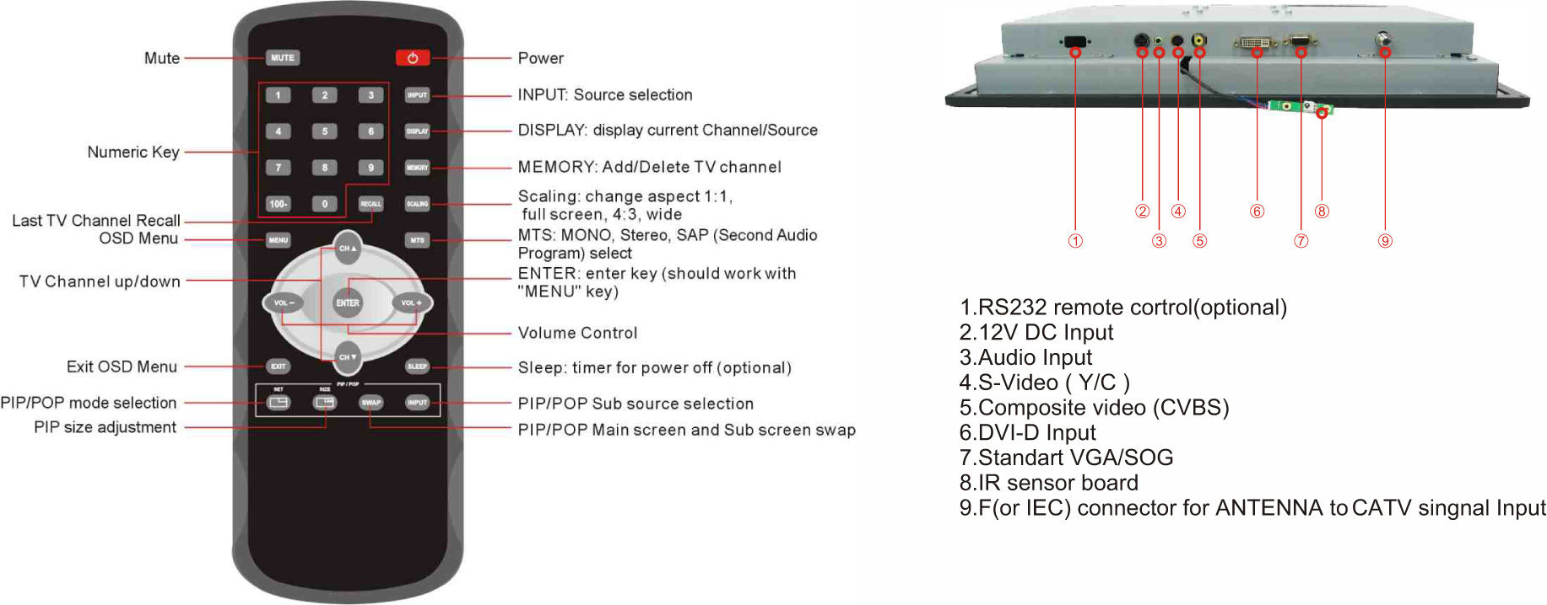
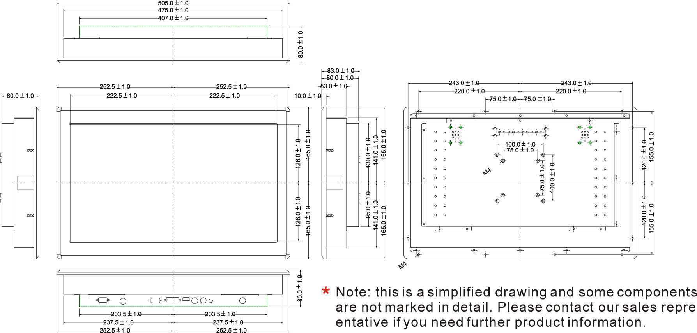
i-Tech Company LLC
TOLL FREE: (888) 483-2418 • EMAIL: info@i-techcompany.com • WEB: www.iTechLCD.com
Control Explanation:
Mechanical Drawing:

