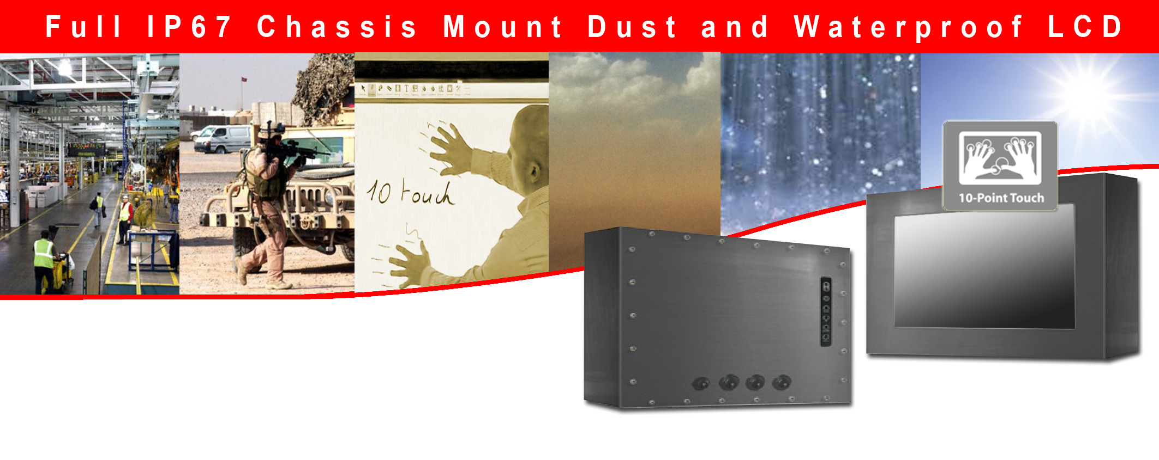

IP67 Chassis w10.1" LCD, 1366x768, LED-200nits, VGA, w/o Speaker, w/ Ext. Adapter, IP67 cables, SECC Metal w/ Powder coating with 10 points Projective Capacitive Touch (1-2mm) USB Controller
(Model: ECH7-W1010B-PCT10)

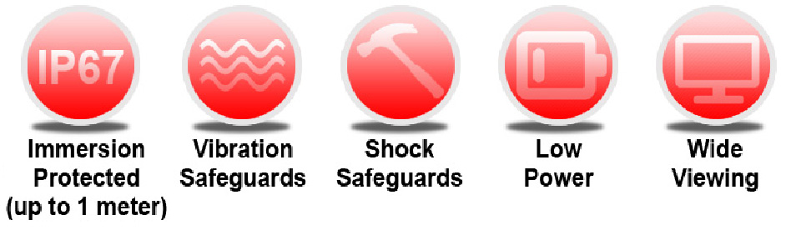
- Modular mechanism design provides flexible product configuration and easy maintenance.
- Optional to built-in touch screen for interactive application.
- Available with auto-brightness sensor offers application in day and night.
- SECC + Powder coating
- Complete custom design/solution for OEM customers
- IP67 Compliant
- Protected against temporary immersion (up to 1 meter for 30 minutes)
- MIL-STD Compliant Connector

Features:

Rugged Completely Sealed IP67/NEMA6 Chassis/Surface Mount LCD Monitor



Water Proof Solution,
Full IP NEMA6 Rating
front and back

Aluminum Housing
Chassis Design
AR Glass
Protective Glass at
front
Optional High
Brightness and
Touch screen
* IP67 Water and Dust proof
connection for a higher protection

* All Connectors are facing backward
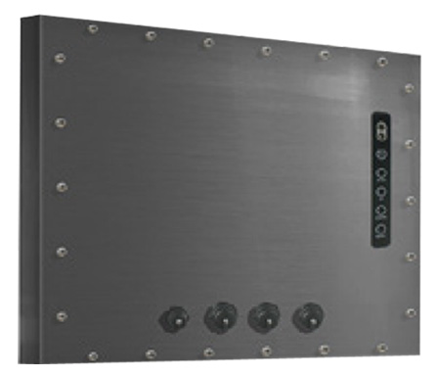



i-Tech Company LLC
TOLL FREE: (888) 483-2418 • EMAIL: info@itechlcd.com • WEB: www.iTechLCD.com
Specification:
Full IP67 Chassis Mount Dust and Waterproof LCD

Panel | Cell Type / Glass Surface | TFT LCD / Black Anti-Glare, low refection coating
Panel | Aspect Ratio / Size | Wide / 10.1" viewable diagonal area
Panel | Active Area / Pixel Pitch | 222.72(H) x 125.28(V) mm / 0.1629(H) x 0.1629(V) mm
Panel | Native Resolution / Colors | 1366(H) x 768(V) / 262 K
Panel | Brightness / Contrast | 200 cd/m² (typ) / 500 : 1
Panel | Response Time | ≤ 16 ms
Panel | Viewing Angle (typical) | H.90o (- 45o ~ + 45o) , V. 50o(- 30o ~ + 20o)
Panel | Light Source | LED backlight, Long life, 35,000 hrs (typ)
Input Sources | PC System | Signal | Analog RGB (0.7/1.0 V_{p-p}, 75 ohms)
Input Sources |  | Sync | Separate Sync, Composite Sync, Sync On Green
Input Sources |  | Frequency | F_{h} : 30 - 82Khz , F_{v} : 50 -75Hz
Input Sources | Audio System | 2W speaker x 2
Input Terminals | 1 x VGA (15 Pin Female D-Sub) , 1 x PC Audio (Stereo Headphone Jack) , 1 x DC Power Plug
Convenient Features | Auto Calibration , Back Light Adjustment , Plug&Play (VESA DDC/CI, DDC 2B)
Convenient Features | OSD Multi-Languages , Wall Mount Ready (VESA Dimension - please refer to Drawing)
Power | External AC-to-12VDC power adapter with universal / Auto-Sensing, AC 90 to 260V, 50 / 60 Hz
Power Consumption | Operation / Power Saving | 8.25 watt , < 1 watt (Support DPMS)
Operating Condition | Temperature / Humidity | 0ºC ~ 50ºC (32ºF ~ 122ºF) , 10% ~ 90% (no condensation)
Storage Condition | Temperature / Humidity | - 20ºC ~ 60ºC (- 4ºF ~ 140ºF) , 10% ~ 90% (no condensation)
Certification |  | FCC , CE
Dimensions | Physical | Please refer to Drawing
Dimensions | Carton | W x H x D = TBD
Weight | N.W. / G.W. | 3.5 Kgs / 4.5 Kgs
Container Loaded | 20ft / 40ft / 40ft HQ | TBD (Sets , By pallet)

Options | Touch | Video / TV | Enhanced Panel | Others
Options | Resistive touch | SV + AV | Panel with LED backlight | Digital Signage(Stand alone)
Options | Capacitive touch | SV + AV + AV Looping | High brightness panel | Networking Digital Signage
Options | SAW touch | SV + AV + TV | Wide Temperature | Motion Sensor
Options | Infrared touch |  | Sunlight Readable | Light Sensor
Options | Protected glass |  |  | Auto-Dimming

Applications:

- Automation
- Batch Processing
- Commercial Broadcast Operations
- Man Machine Interface (MMI) Operation
- Electronic Flight Bag (EFB)
- Food Processing
- GPS Mapping Systems
- Inspection Systems

Mechanical Drawing:
Full IP67 Chassis Mount Dust and Waterproof LCD

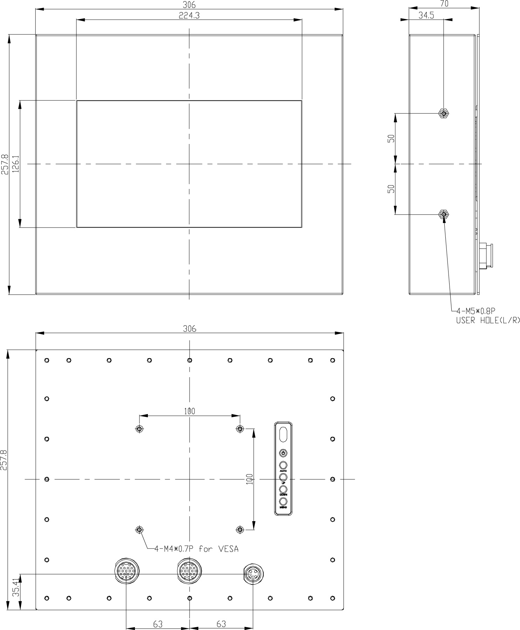

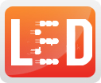



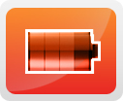

LCD Options:
Full IP67 Chassis Mount Dust and Waterproof LCD

LED Backlight Options
Introducing LED backlight options for monitors for energy efficiency and a brighter screen.
VIDEO Input Options:
For Video inputs options:
DVI, DVI+HDMI, SVideo+AV, SVideo+AV+DVI, AV+Looping, DVI+AV+Looping, HD-SDI, BNC(PAL/NTSC)

Optical Bonding Options
- Optical Bonding provides the best reduction of ambient light washout of any commercially available enhancement technology.
- Optical Bonding has a lower cost than most other competing technologies.
- Optical Bonding offers superior ruggedization, enhancing the display durability under vibration, shock and other environmental extremes.
RS-232 Remote Control Options
Remote Control Protocol: Command Code to set system
9-36V DC Input Options
iTech offers a selection of DC input from 9V to 36V
Light Sensor and Motion Sensor Options
iTech LCD offers Light and Motion Sensor
Privacy Filter
Front Glass Options:
- Anti Reflective AR Glass 3mm
- Anti Reflective AR Glass 6mm Vandal-Resistance
- Anti Reflective AR Glass 8mm Vandal-Resistance
- Anti Glare AG Glass 3mm

i-Tech Company LLC
TOLL FREE: (888) 483-2418 • EMAIL: info@itechlcd.com • WEB: www.iTechLCD.com

