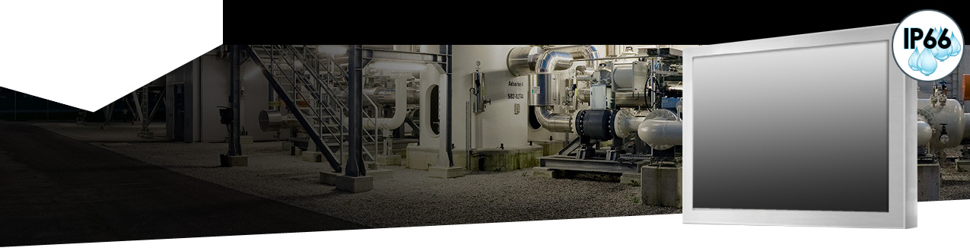
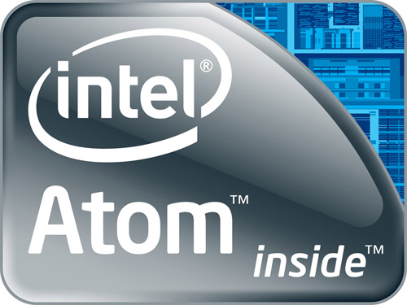

12.1" LCD monitor , Resolution 800 x 600, 1000 nits, with 3mm AR glass, Intel Atom BayTrail, Celeron-J1900 quad cores processor, 2.0GHz Integrated in Fanless , Memory 4GB, 32 GB SSD, Water proof cable: 1 x COM, 1 x VGA, 2 x USB, 1 x LAN, 1 x Power with Projective Capacitive Touch (1-2mm) USB Controller
Model: ECH1210HB-SIP-BT-PCT
FULL IP66 Fanless Panel PC
Rugged Completely Sealed Full IP66/NEMA4X Stainless Steel Chassis/Surface Mount

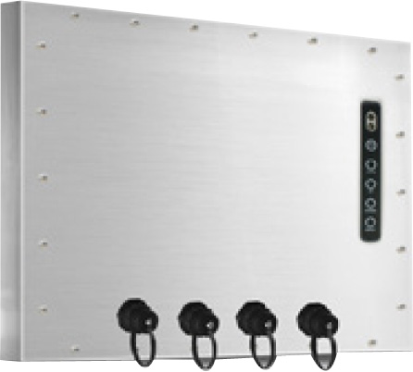

FEATURES:
- Modularize mechanical design provides flexible product configuration and easy maintenance
- Optional build-in touch screen for interactive application
- Intel® Atom Baytrail-M/D Chipset
- Intel® Celeron J1900
- Single Channel DDR3L 1333 MHz SDRAM
- Power x1, VGA x 1 output, RS232 + Audio, LAN x 2, USB x 3
- IP66 Compliant

SPECIFICATIONS:

Panel | Cell Type / Glass Surface | TFT LCD / Black Anti-Glare, low refection coating
 | Aspect Ratio / Size | 4 : 3 / 12.1" viewable diagonal area
 | Active Area / Pixel Pitch | 246.0(H) x 184.5(V) mm / 0.3075(H) x 0.3075(V) mm
 | Native Resolution / Colors | 800(H) x 600(V) / 262 K
 | Brightness / Contrast | 1000 cd/m2 (typ) / 600 : 1
 | Response Time | ≤ 35 ms
 | Viewing Angle (typical) | H. 140o (- 70o ~ + 70o) , V. 120o(- 60o ~ + 60o)
 | Light Source | LED backlight, Long life, 35,000 hrs (typ)
System | CPU | Intel® Celeron J1900
 | BIOS | AMI
 | System / Graphic Chipset | Intel® Atom Baytrail-M/D Chipset
 | System Memory | Single Channel DDR3L 1333 MHz SDRAM
 | HDD | 2 x SATA
 | I/O port | 1 x VGA
 |  | 2 x USB
 |  | 1 x COM
 |  | 1 x LAN
 | Expansion | N / A
Power | Power Input | 12V DC-IN (Lockable connector)
 | Power Consumption | 34Watt, <1 Watt
Operating Condition | Temperature / Humidity | 0ºC ~ 50ºC (32ºF ~ 122ºF) , 10% ~ 90% (no condensation)
Dimensions | Physical | Please refer to Drawing
 | Carton | W x H x D = TBD

Options | Touch | Video / TV | Enhanced Panel | Others
 | Resistive touch | SV + AV | Panel with LED backlight | Digital Signage(Stand alone)
 | Capacitive touch | SV + AV + AV_Looping | High brightness panel | Networking Digital Signage
 | SAW touch | SV + AV + TV | Wide Temperature | Motion Sensor
 | Infrared touch |  | Sunlight Readable | Light Sensor
 | Protected glass |  |  | Auto-Dimming



i-Tech Company LLC
TOLL FREE: (888) 483-2418 • EMAIL: info@itechlcd.com • WEB: www.iTechLCD.com


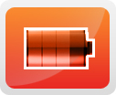

LCD OPTIONS
Optical Bonding Options
- Optical Bonding provides the best reduction of ambient light washout of any commercially available enhancement technology.
- Optical Bonding has a lower cost than most other competing technologies.
- Optical Bonding offers superior ruggedization, enhancing the display durability under vibration, shock and other environmental extremes.
RS-232 Remote Control Options
Remote Control Protocol: Command Code to set system
9-36V DC Input Options
iTech offers a selection of DC input from 9V to 36V
Light Sensor and Motion Sensor Options
iTech LCD offers Light and Motion Sensor
Privacy Filter
Front Glass Options:
- Anti Reflective AR Glass 3mm
- Anti Reflective AR Glass 6mm Vandal-Resistance
- Anti Reflective AR Glass 8mm Vandal-Resistance
- Anti Glare AG Glass 3mm

DRAWINGS:

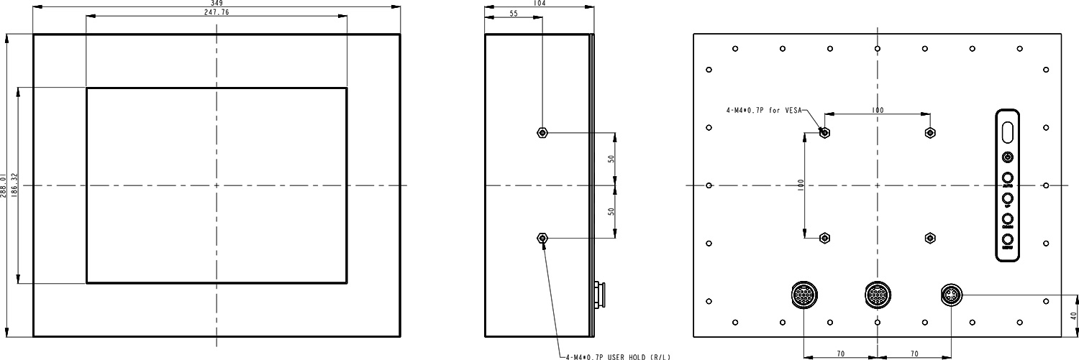

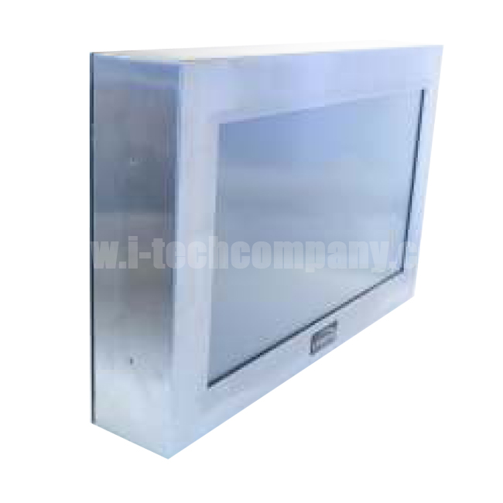
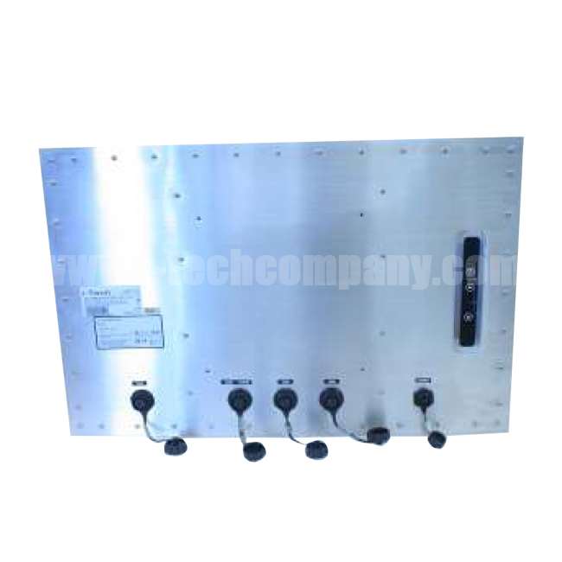
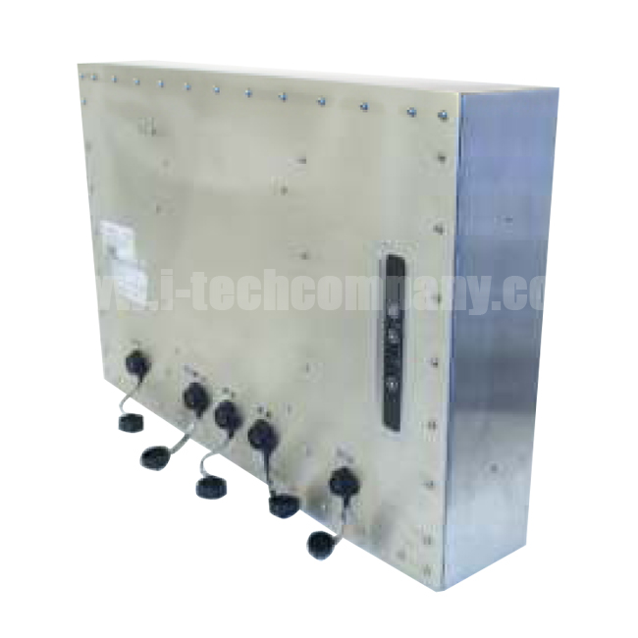
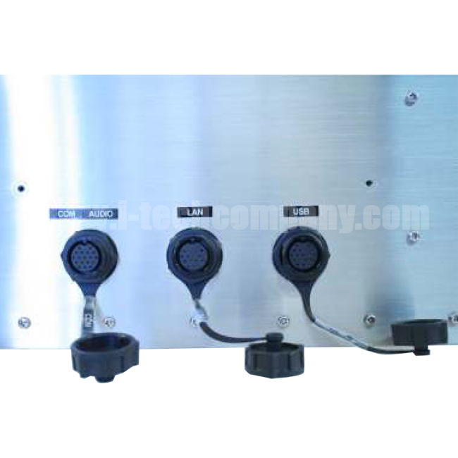
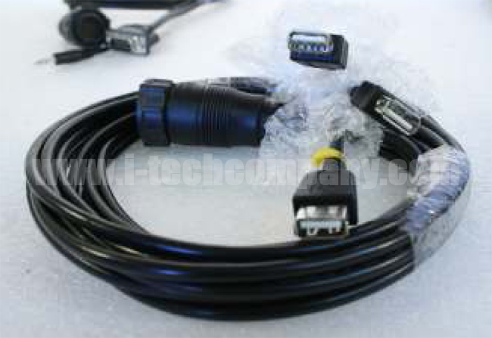
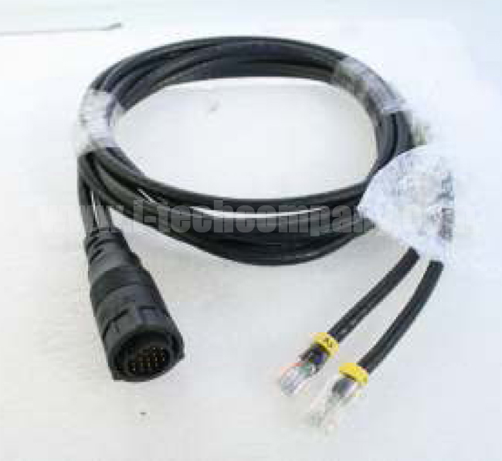
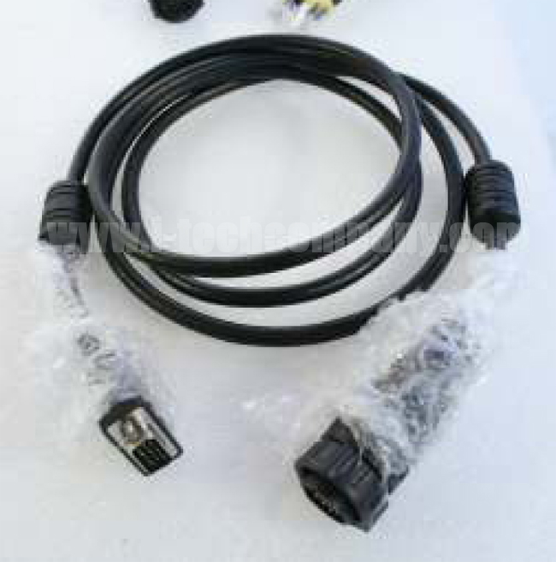
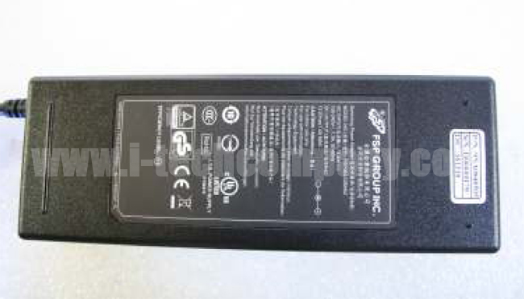
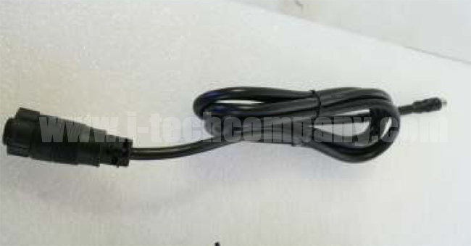
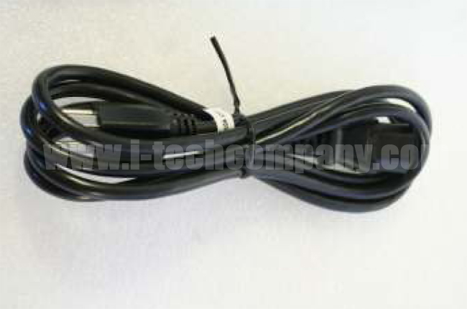
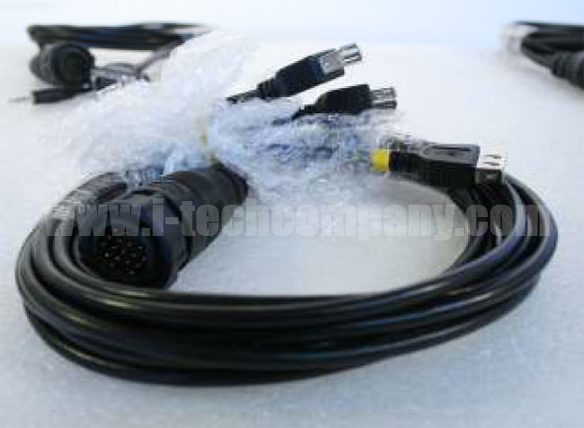
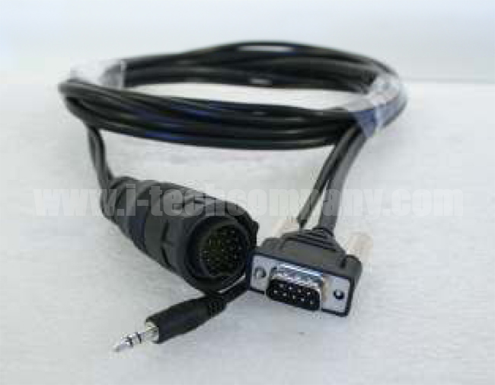
PHOTO GALLERY:

i-Tech Company LLC
TOLL FREE: (888) 483-2418 • EMAIL: info@itechlcd.com • WEB: www.iTechLCD.com

